**WEEK 3 : SPRING CORE MAVEN**

**SUPERSET ID : 6399056**

**Exercise 1: Configuring a Basic Spring Application**

**Pom.xml**

<project xmlns="http://maven.apache.org/POM/4.0.0"

xmlns:xsi="http://www.w3.org/2001/XMLSchema-instance"

xsi:schemaLocation="http://maven.apache.org/POM/4.0.0

http://maven.apache.org/xsd/maven-4.0.0.xsd">

<modelVersion>4.0.0</modelVersion>

<groupId>com.library</groupId>

<artifactId>LibraryManagement</artifactId>

<version>1.0-SNAPSHOT</version>

<dependencies>

<dependency>

<groupId>org.springframework</groupId>

<artifactId>spring-context</artifactId>

<version>5.3.34</version>

</dependency>

</dependencies>

</project>

**BookRepository.java**

package com.library.repository;

public class BookRepository {

public void saveBook(String bookName) {

System.out.println("Book saved: " + bookName);

}

}

**BookService.java**

package com.library.service;

import com.library.repository.BookRepository;

public class BookService {

private BookRepository bookRepository;

public void setBookRepository(BookRepository bookRepository) {

this.bookRepository = bookRepository;

}

public void addBook(String bookName) {

bookRepository.saveBook(bookName);

}

}

**MainApp.java**

package com.library;

import com.library.service.BookService;

import org.springframework.context.ApplicationContext;

import org.springframework.context.support.ClassPathXmlApplicationContext;

public class MainApp {

public static void main(String[] args) {

ApplicationContext context = new ClassPathXmlApplicationContext("applicationContext.xml");

BookService bookService = (BookService) context.getBean("bookService");

bookService.addBook("The Great Gatsby");

}

}

**Applicationcontext.xml**

<?xml version="1.0" encoding="UTF-8"?>

<beans xmlns="http://www.springframework.org/schema/beans"

xmlns:xsi="http://www.w3.org/2001/XMLSchema-instance"

xsi:schemaLocation="

http://www.springframework.org/schema/beans

http://www.springframework.org/schema/beans/spring-beans.xsd">

<bean id="bookRepository" class="com.library.repository.BookRepository" />

<bean id="bookService" class="com.library.service.BookService">

<property name="bookRepository" ref="bookRepository" />

</bean>

</beans>

**OUTPUT**

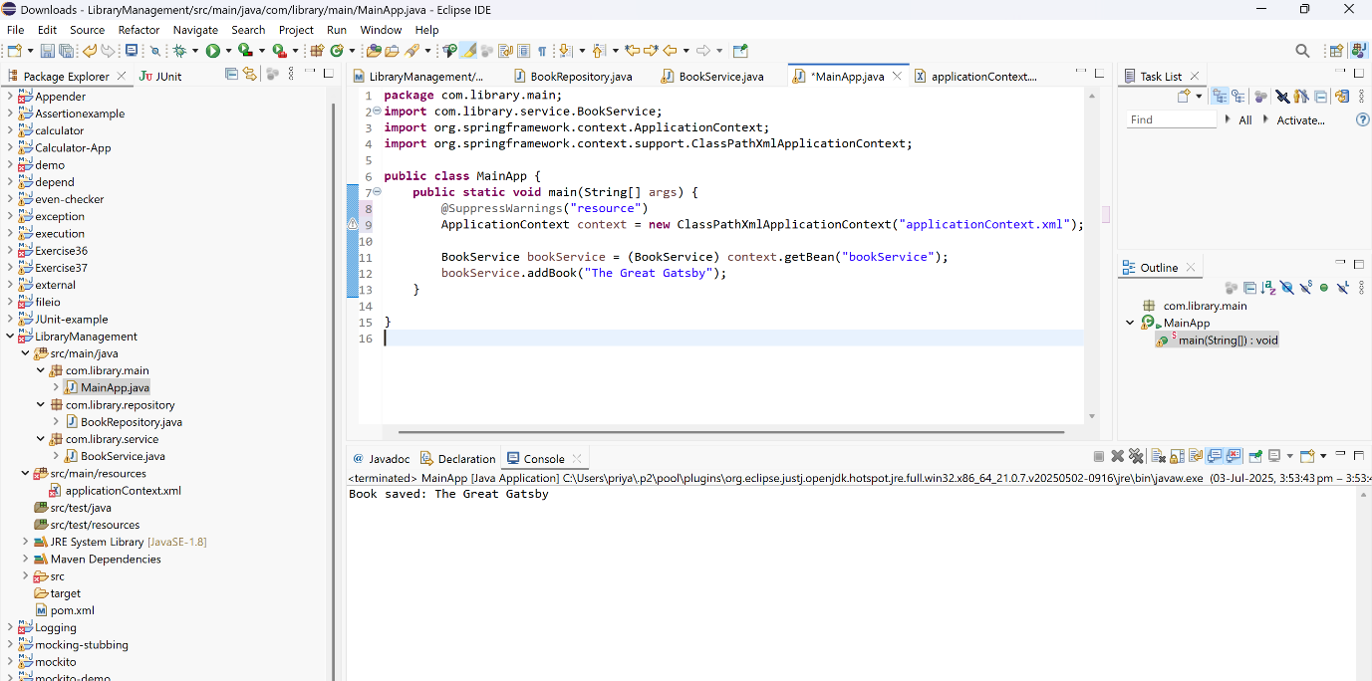

**Exercise 2 : Implementing Dependency Injection**

**BookRepository.java**

package com.library.service;

import com.library.repository.BookRepository;

public class BookService {

private BookRepository bookRepository;

public void setBookRepository(BookRepository bookRepository) {

this.bookRepository = bookRepository;

}

public void addBook(String bookName) {

bookRepository.saveBook(bookName);

}

}

**applicationContext.xml**

<?xml version="1.0" encoding="UTF-8"?>

<beans xmlns="http://www.springframework.org/schema/beans"

xmlns:xsi="http://www.w3.org/2001/XMLSchema-instance"

xsi:schemaLocation="

http://www.springframework.org/schema/beans

http://www.springframework.org/schema/beans/spring-beans.xsd">

<bean id="bookRepository" class="com.library.repository.BookRepository" />

<bean id="bookService" class="com.library.service.BookService">

<property name="bookRepository" ref="bookRepository"/>

</bean>

</beans>

**MainApp.java**

package com.library;

import com.library.service.BookService;

import org.springframework.context.ApplicationContext;

import org.springframework.context.support.ClassPathXmlApplicationContext;

public class MainApp {

public static void main(String[] args) {

ApplicationContext context = new ClassPathXmlApplicationContext("applicationContext.xml");

BookService bookService = (BookService) context.getBean("bookService");

bookService.addBook("To Kill a Mockingbird");

}

}

**OUTPUT**

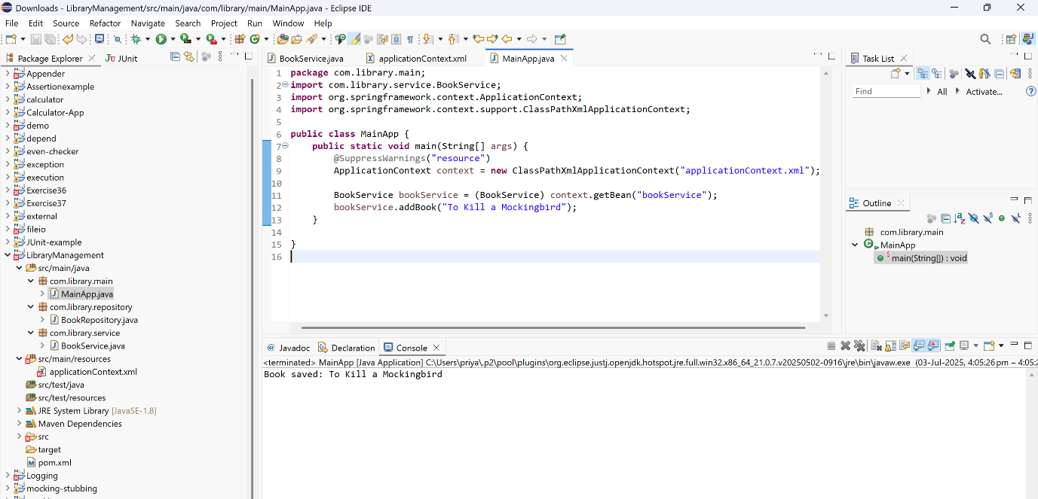

**Exercise 3 : Implementing Logging with Spring AOP**

**Pom.xml**

<dependencies>

<dependency>

<groupId>org.springframework</groupId>

<artifactId>spring-context</artifactId>

<version>5.3.34</version>

</dependency>

<dependency>

<groupId>org.springframework</groupId>

<artifactId>spring-aspects</artifactId>

<version>5.3.34</version>

</dependency>

</dependencies>

**LoggingAspect.java**

package com.library.aspect;

import org.aspectj.lang.ProceedingJoinPoint;

public class LoggingAspect {

public Object logExecutionTime(ProceedingJoinPoint joinPoint) throws Throwable {

long start = System.currentTimeMillis();

Object result = joinPoint.proceed();

long end = System.currentTimeMillis();

System.out.println("[LOG] Method " + joinPoint.getSignature().getName() +

" executed in " + (end - start) + " ms");

return result;

}

}

**ApplicationContext.xml**

<?xml version="1.0" encoding="UTF-8"?>

<beans xmlns="http://www.springframework.org/schema/beans"

xmlns:xsi="http://www.w3.org/2001/XMLSchema-instance"

xmlns:aop="http://www.springframework.org/schema/aop"

xsi:schemaLocation="

http://www.springframework.org/schema/beans

http://www.springframework.org/schema/beans/spring-beans.xsd

http://www.springframework.org/schema/aop

http://www.springframework.org/schema/aop/spring-aop.xsd">

<bean id="bookRepository" class="com.library.repository.BookRepository" />

<bean id="bookService" class="com.library.service.BookService">

<property name="bookRepository" ref="bookRepository"/>

</bean>

<bean id="loggingAspect" class="com.library.aspect.LoggingAspect" />

<aop:config>

<aop:aspect id="logAspect" ref="loggingAspect">

<aop:around method="logExecutionTime" pointcut="execution(* com.library.service.*.*(..))"/>

</aop:aspect>

</aop:config>

</beans>

**MainApp.java**

package com.library;

import com.library.service.BookService;

import org.springframework.context.ApplicationContext;

import org.springframework.context.support.ClassPathXmlApplicationContext;

public class MainApp {

public static void main(String[] args) {

ApplicationContext context = new ClassPathXmlApplicationContext("applicationContext.xml");

BookService bookService = (BookService) context.getBean("bookService");

bookService.addBook("1984 by George Orwell");

}

}

**OUTPUT**

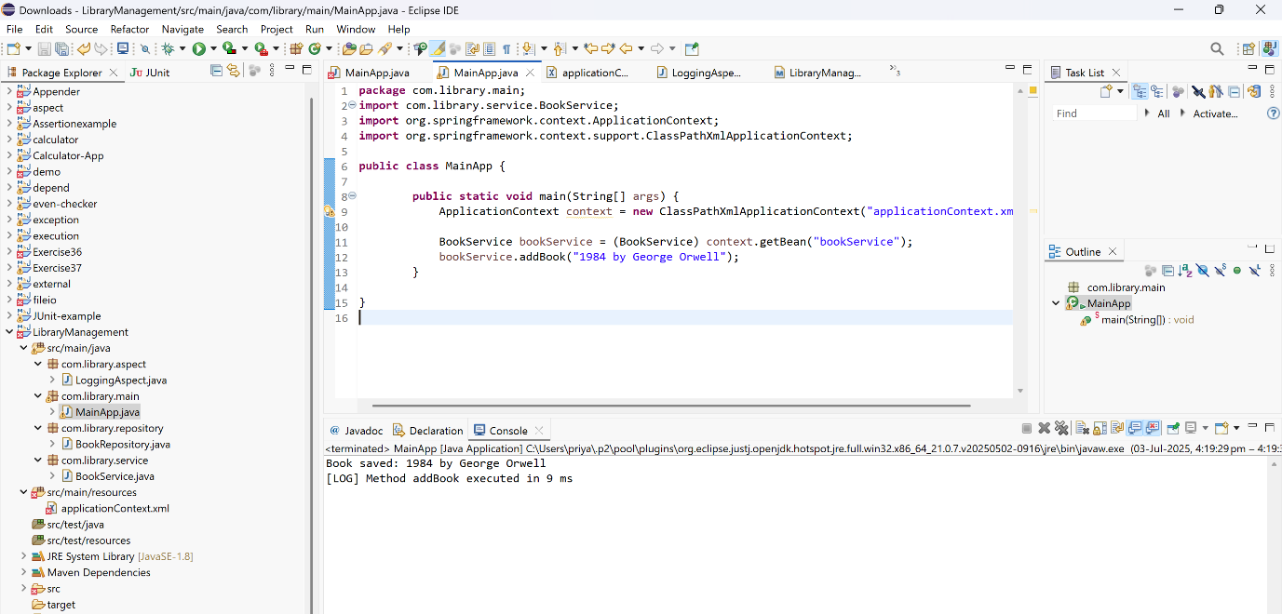

**Exercise 4 : Creating and Configuring a Maven Project**

**Pom.xml**

<dependencies>

<dependency>

<groupId>org.springframework</groupId>

<artifactId>spring-context</artifactId>

<version>5.3.34</version>

</dependency>

<dependency>

<groupId>org.springframework</groupId>

<artifactId>spring-aspects</artifactId>

<version>5.3.34</version>

</dependency>

<dependency>

<groupId>org.springframework</groupId>

<artifactId>spring-webmvc</artifactId>

<version>5.3.34</version>

</dependency>

<dependency>

<groupId>javax.servlet</groupId>

<artifactId>javax.servlet-api</artifactId>

<version>4.0.1</version>

<scope>provided</scope>

</dependency>

</dependencies>

**Maven compiler**

<build>

<plugins>

<plugin>

<groupId>org.apache.maven.plugins</groupId>

<artifactId>maven-compiler-plugin</artifactId>

<version>3.10.1</version>

<configuration>

<source>1.8</source>

<target>1.8</target>

</configuration>

</plugin>

</plugins>

</build>

**MainApp.java**

package com.library.main;

import com.library.service.BookService;

import org.springframework.context.ApplicationContext;

import org.springframework.context.support.ClassPathXmlApplicationContext;

public class MainApp {

public static void main(String[] args) {

ApplicationContext context = new ClassPathXmlApplicationContext("applicationContext.xml");

BookService service = context.getBean(BookService.class);

service.addBook("The Hobbyy");

}

}

**OUTPUT**

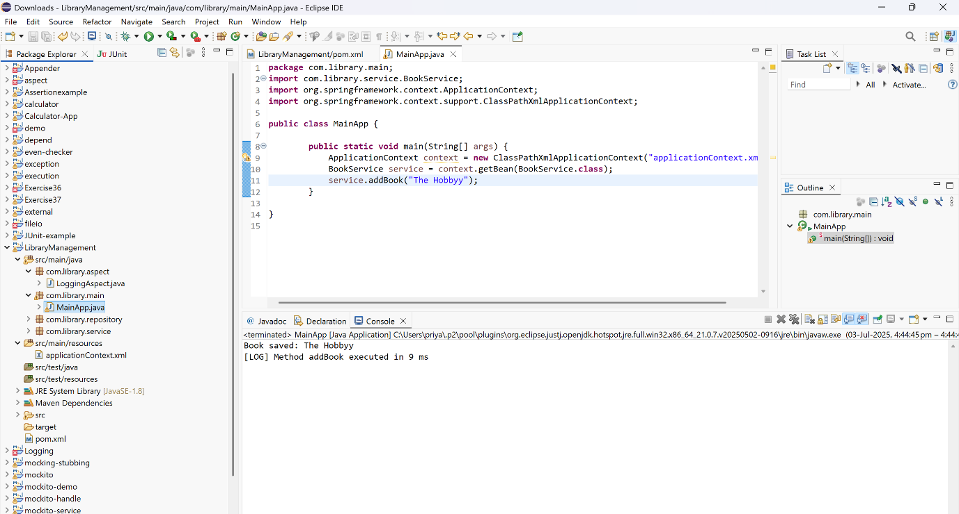

**Exercise 5: Configuring the Spring IoC Container**

**applicationContext.xml**

<?xml version="1.0" encoding="UTF-8"?>

<beans xmlns="http://www.springframework.org/schema/beans"

xmlns:xsi="http://www.w3.org/2001/XMLSchema-instance"

xsi:schemaLocation="

http://www.springframework.org/schema/beans

http://www.springframework.org/schema/beans/spring-beans.xsd">

<bean id="bookRepository" class="com.library.repository.BookRepository" />

<bean id="bookService" class="com.library.service.BookService">

<property name="bookRepository" ref="bookRepository"/>

</bean>

</beans>

**BookService.java**

package com.library.service;

import com.library.repository.BookRepository;

public class BookService {

private BookRepository bookRepository;

public void setBookRepository(BookRepository bookRepository) {

this.bookRepository = bookRepository;

}

public void addBook(String bookName) {

bookRepository.saveBook(bookName);

}

}

**BookRepository.java**

package com.library.repository;

public class BookRepository {

public void saveBook(String bookName) {

System.out.println("Book saved: " + bookName);

}

}

**MainApp.java**

package com.library;

import com.library.service.BookService;

import org.springframework.context.ApplicationContext;

import org.springframework.context.support.ClassPathXmlApplicationContext;

public class MainApp {

public static void main(String[] args) {

ApplicationContext context = new ClassPathXmlApplicationContext("applicationContext.xml");

BookService bookService = (BookService) context.getBean("bookService");

bookService.addBook("The Alchemist");

}

}

**OUTPUT**

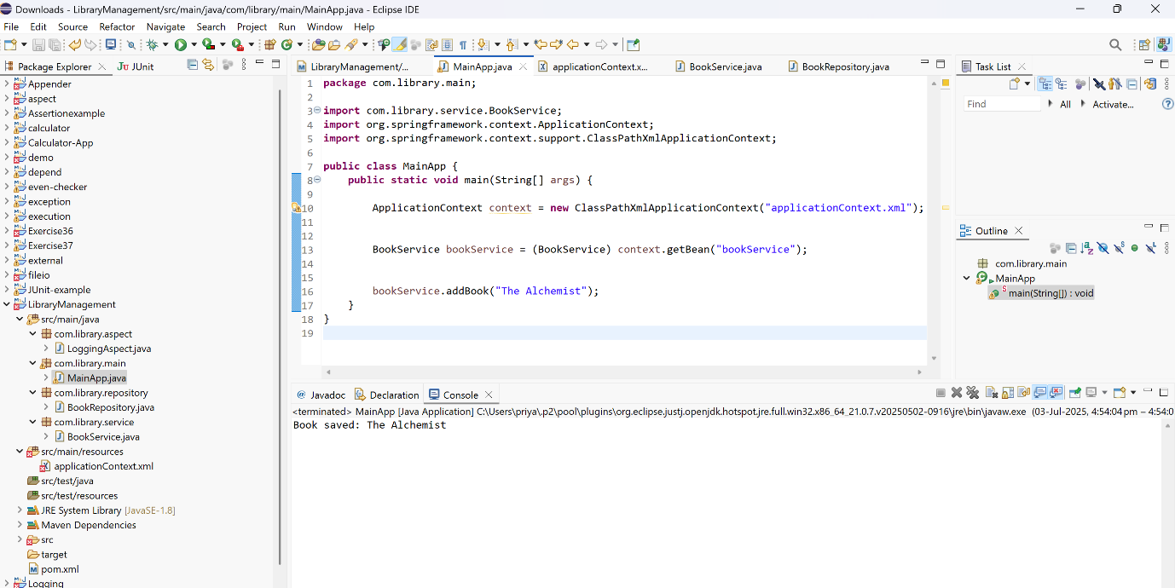

**Exercise 6: Configuring Beans with Annotations**

**applicationContext.xml**

<?xml version="1.0" encoding="UTF-8"?>

<beans xmlns="http://www.springframework.org/schema/beans"

xmlns:context="http://www.springframework.org/schema/context"

xmlns:xsi="http://www.w3.org/2001/XMLSchema-instance"

xsi:schemaLocation="

http://www.springframework.org/schema/beans

http://www.springframework.org/schema/beans/spring-beans.xsd

http://www.springframework.org/schema/context

http://www.springframework.org/schema/context/spring-context.xsd">

<context:component-scan base-package="com.library"/>

</beans>

**BookRepository.java**

package com.library.repository;

import org.springframework.stereotype.Repository;

@Repository

public class BookRepository {

public void saveBook(String bookName) {

System.out.println("Book saved: " + bookName);

}

}

**BookService.java**

package com.library.service;

import com.library.repository.BookRepository;

import org.springframework.beans.factory.annotation.Autowired;

import org.springframework.stereotype.Service;

@Service

public class BookService {

private BookRepository bookRepository;

@Autowired

public void setBookRepository(BookRepository bookRepository) {

this.bookRepository = bookRepository;

}

public void addBook(String bookName) {

bookRepository.saveBook(bookName);

}

}

**MainApp.java**

package com.library;

import com.library.service.BookService;

import org.springframework.context.ApplicationContext;

import org.springframework.context.support.ClassPathXmlApplicationContext;

public class MainApp {

public static void main(String[] args) {

ApplicationContext context = new ClassPathXmlApplicationContext("applicationContext.xml");

BookService service = context.getBean(BookService.class);

service.addBook("Harry Potter and the Philosopher's Stone");

}

}

**OUTPUT**

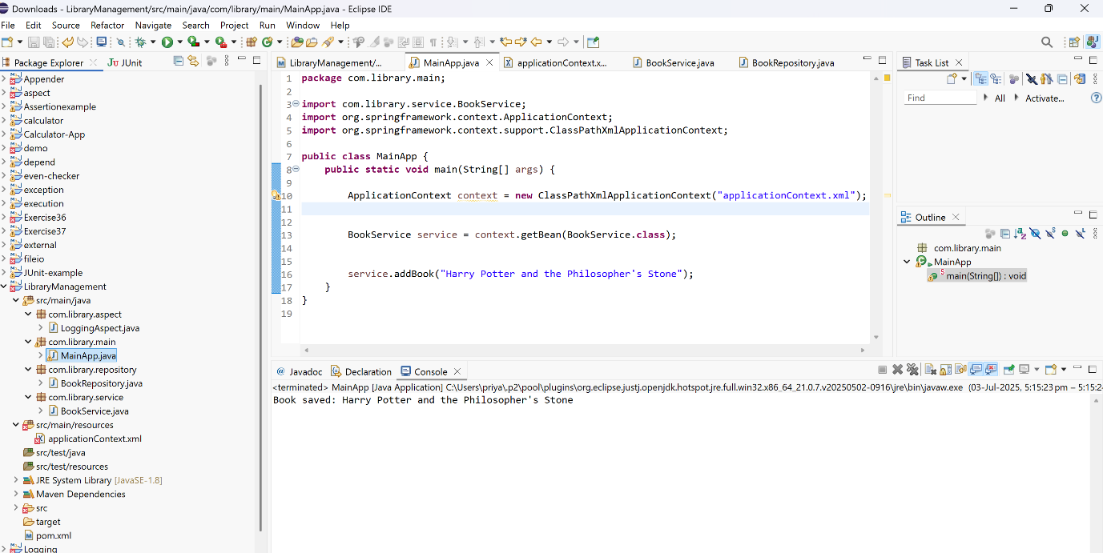

**Exercise 7: Implementing Constructor and Setter Injection**

**BookRepository.java**

package com.library.repository;

public class BookRepository {

public void saveBook(String bookName) {

System.out.println("Book saved: " + bookName);

}

}

**BookService.java**

package com.library.service;

import com.library.repository.BookRepository;

public class BookService {

private String libraryName;

private BookRepository bookRepository;

public BookService(String libraryName) {

this.libraryName = libraryName;

System.out.println("Library Name set via constructor: " + libraryName);

}

public void setBookRepository(BookRepository bookRepository) {

this.bookRepository = bookRepository;

}

public void addBook(String bookName) {

bookRepository.saveBook(bookName);

}

}

**applicationContext.xml**

<?xml version="1.0" encoding="UTF-8"?>

<beans xmlns="http://www.springframework.org/schema/beans"

xmlns:xsi="http://www.w3.org/2001/XMLSchema-instance"

xsi:schemaLocation="

http://www.springframework.org/schema/beans

http://www.springframework.org/schema/beans/spring-beans.xsd">

<bean id="bookRepository" class="com.library.repository.BookRepository" />

<bean id="bookService" class="com.library.service.BookService">

<!-- Constructor injection (for String value) -->

<constructor-arg value="Kavi Library"/>

<property name="bookRepository" ref="bookRepository"/>

</bean>

</beans>

**MainApp.java**

package com.library.main;

import com.library.service.BookService;

import org.springframework.context.ApplicationContext;

import org.springframework.context.support.ClassPathXmlApplicationContext;

public class MainApp {

public static void main(String[] args) {

ApplicationContext context = new ClassPathXmlApplicationContext("applicationContext.xml");

BookService service = context.getBean(BookService.class);

service.addBook("Wings of Fire");

}

}

**OUTPUT**

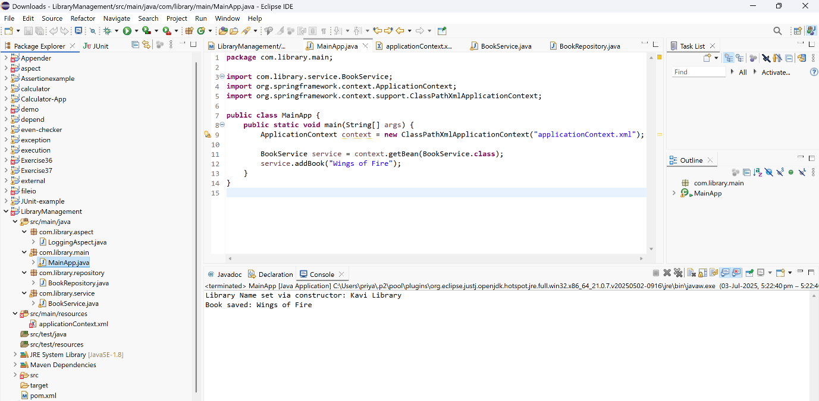

**Exercise 8: Implementing Basic AOP with Spring**

**Pom.xml**

<dependency>

<groupId>org.springframework</groupId>

<artifactId>spring-aspects</artifactId>

<version>5.3.34</version>

</dependency>

**LoggingAspect.java**

package com.library.aspect;

import org.aspectj.lang.JoinPoint;

import org.aspectj.lang.annotation.After;

import org.aspectj.lang.annotation.Aspect;

import org.aspectj.lang.annotation.Before;

import org.springframework.stereotype.Component;

@Aspect

@Component

public class LoggingAspect {

@Before("execution(* com.library.service.BookService.*(..))")

public void beforeAdvice(JoinPoint joinPoint) {

System.out.println(" [LOG] Before Method: " + joinPoint.getSignature().getName());

}

@After("execution(* com.library.service.BookService.*(..))")

public void afterAdvice(JoinPoint joinPoint) {

System.out.println("[LOG] After Method: " + joinPoint.getSignature().getName());

}

}

**ApplicationContext.xml**

<?xml version="1.0" encoding="UTF-8"?>

<beans xmlns="http://www.springframework.org/schema/beans"

xmlns:context="http://www.springframework.org/schema/context"

xmlns:aop="http://www.springframework.org/schema/aop"

xmlns:xsi="http://www.w3.org/2001/XMLSchema-instance"

xsi:schemaLocation="

http://www.springframework.org/schema/beans

http://www.springframework.org/schema/beans/spring-beans.xsd

http://www.springframework.org/schema/context

http://www.springframework.org/schema/context/spring-context.xsd

http://www.springframework.org/schema/aop

http://www.springframework.org/schema/aop/spring-aop.xsd">

<context:component-scan base-package="com.library"/>

<aop:aspectj-autoproxy/>

</beans>

**BookService.java**

package com.library.service;

import com.library.repository.BookRepository;

import org.springframework.beans.factory.annotation.Autowired;

import org.springframework.stereotype.Service;

@Service

public class BookService {

private BookRepository bookRepository;

@Autowired

public void setBookRepository(BookRepository bookRepository) {

this.bookRepository = bookRepository;

}

public void addBook(String bookName) {

bookRepository.saveBook(bookName);

}

}

**MainApp.java**

package com.library.main;

import com.library.service.BookService;

import org.springframework.context.ApplicationContext;

import org.springframework.context.support.ClassPathXmlApplicationContext;

public class MainApp {

public static void main(String[] args) {

ApplicationContext context = new ClassPathXmlApplicationContext("applicationContext.xml");

BookService service = context.getBean(BookService.class);

service.addBook("Zero to One");

}

}

**OUTPUT**

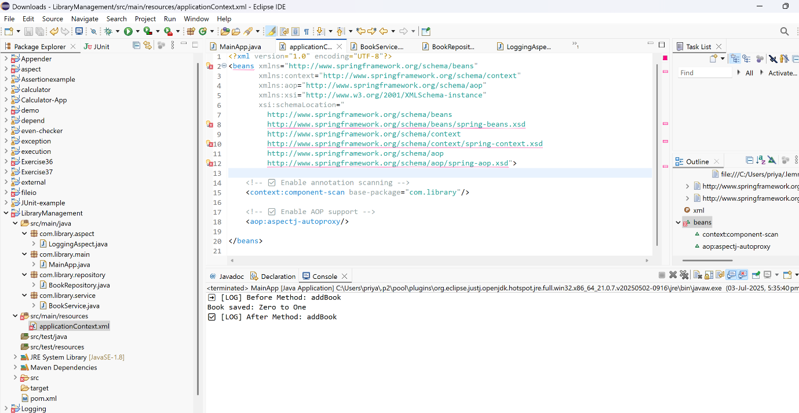

**Exercise 9: Creating a Spring Boot Application**

**Book.java**

package com.library.librarymanagement.entity;

import jakarta.persistence.*;

@Entity

public class Book {

@Id

@GeneratedValue(strategy = GenerationType.IDENTITY)

private Long id;

private String title;

private String author;

public Long getId() {

return id;

}

public void setId(Long id) {

this.id = id;

}

public String getTitle() {

return title;

}

public void setTitle(String title) {

this.title = title;

}

public String getAuthor() {

return author;}

public void setAuthor(String author) {

this.author = author;

}}

**BookRepository.java**

package com.library.librarymanagement.repository;

import com.library.librarymanagement.entity.Book;

import org.springframework.data.jpa.repository.JpaRepository;

public interface BookRepository extends JpaRepository<Book, Long> {

}

**BookController.java**

package com.library.librarymanagement.controller;

import com.library.librarymanagement.entity.Book;

import com.library.librarymanagement.repository.BookRepository;

import org.springframework.beans.factory.annotation.Autowired;

import org.springframework.web.bind.annotation.*;

import java.util.List;

@RestController

@RequestMapping("/api/books")

public class BookController {

@Autowired

private BookRepository bookRepository;

@GetMapping

public List<Book> getAllBooks() {

return bookRepository.findAll();

}

@PostMapping

public Book createBook(@RequestBody Book book) {

return bookRepository.save(book);

}

@GetMapping("/{id}")

public Book getBook(@PathVariable Long id) {

return bookRepository.findById(id).orElse(null);

}

@PutMapping("/{id}")

public Book updateBook(@PathVariable Long id, @RequestBody Book updatedBook) {

return bookRepository.findById(id)

.map(book -> {

book.setTitle(updatedBook.getTitle());

book.setAuthor(updatedBook.getAuthor());

return bookRepository.save(book);

}).orElse(null);

}

@DeleteMapping("/{id}")

public void deleteBook(@PathVariable Long id) {

bookRepository.deleteById(id);

}

}

**LibraryManagementApplication.java**

package com.library.librarymanagement;

import org.springframework.boot.SpringApplication;

import org.springframework.boot.autoconfigure.SpringBootApplication;

@SpringBootApplication

public class LibraryManagementApplication {

public static void main(String[] args) {

SpringApplication.run(LibraryManagementApplication.class, args);

}

}